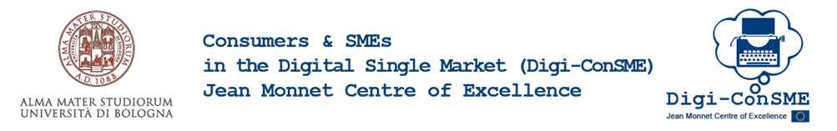

presents
Short Course Thought Leaders Webinar

SMEs and Digital technologies in EU regulations

18 May 2021, 14.00 - 18.00

We inform that the webinar will be recorded for academic purposes only

The Short Course investigates the European public regulation of Small and Medium-sized enterprises in relation to new ICT technologies and funding channels.

Programme

Opening Remarks:

Prof.ssa Maria Alessandra Stefanelli, Full Professor of Economics Law, University of Bologna, Supervisor of the Short Course of the Jean Monnet Centre of Excellence
Dott.ssa Elisabetta Pistocchi, Director of Formart, Professional Training Company of Confartigianato Imprese Emilia-Romagna
Prof. Federico Ferretti, Associate Professor of Economics Law, University of Bologna, Director of the Jean Monnet Centre of Excellence
Prof. Nicola Soldati, Associate Professor of Economics Law, University of Bologna, Coordinator of the Short Courses of the Jean Monnet Centre of Excellence

Speakers:

Prof. Paolo Borghi, Full Professor of Agri-food Law, University of Ferrara: No Country for New Food (nor for New Food Businesses)
Avv. Stefano Fratta, Privacy Policy Director EMEA Facebook: Privacy Regulations and new technologies
Dott.ssa Valentina Corbetta, Strategist and Communications Director - QUAAB: Where are you going? - Consumers and SMEs in the Digital Single Market
Prof. Giuliano Lemme, Full Professor of Economics Law, University of Modena and Reggio Emilia: Crowdfunding and innovative finance for SME’s
Prof. Riccardo De Caria, Assistant Professor of Comparative Public Law, University of Torino: SMEs and blockchain technologies: the role of the law in moving "from buzz to bucks"
Prof. Enrico Santarelli, Full Professor of Economic Policy, University of Bologna: AI and Robots: Towards a New Techno-Economic Paradigm

About Digi-ConSME
“Consumers and SMEs in the Digital Single Market (Digi-ConSME)” is the name of the newly established Jean Monnet Centre of Excellence that has been awarded by the European Commission to the Department of Sociology and Economic Law of the University of Bologna. A Jean Monnet Centre of Excellence is a focal point of competence and knowledge on European Union studies. It is awarded to outstanding research groups that have a visible societal impact and do pioneering research at international level.

Register here
https://eventi.unibo.it/jm-short-courses/seminario-n-4-smes-and-digital-technologies-in-eu-regulations

If you have any question regarding the Short Course, please feel free to contact:
Dott.ssa Beatrice Bertarini (beatrice.bertarini2@unibo.it)

Visit our website:
https://site.unibo.it/digi-consme/en

Kind regards,
Digi-ConSME
Prof.sa Maria Alessandra Stefanelli

